Optimized and Automated Organ Matching and Donation System using Python with Real-Time Notifications

Soundarya R ,ManjuThershiniS, Magakaviya M, Mukila V.
manjufms5319@gmail.com,mahamurugantamil@gmail.com,mukilavelusamy@gmail.com
Department of Computer Science and Engineering
VEL TECH HIGH TECH DR.RANGARAJAN DR.SAKUNTHALA ENGINEERING COLLEGE

Abstract:
Although organ donation and matching are vital procedures that have the potential to save lives, they are frequently limited by time delays and inefficiency in getting the organ. In order to improve organ donation and matching, this study proposes a Python-based system that uses real-time notifications to facilitate communication between healthcare providers, donors, and receivers. This approach makes use of real-time data and sophisticated matching algorithms to guarantee and prompt efficient organ distribution, reduce waste, and increase the number of successful transplants. To ensure quick reaction times, the system has a notification module to deliver real-time updates to the user. We illustrate the intented result of this strategy in enhancing the environment for organ donation by a thorough study, simulation, and case studies.

Keywords::
Organ donation, automated matching, Python, real-time notifications, block chain, healthcare optimization, organ transplantation, machine learning.

INTRODUCTION:
Organ transplantation is a life-saving medical operation, there is a much greater demand for organs than there are available. Global data show that thousands of patients pass away every year while they wait for eligible donors. This issue is made worse by the inefficiencies in the current organ donation procedures, which include poor matching and communication delays. Programming language technological developments like Python present chances to overcome these obstacles.
Furthermore, a variety of criteria, including blood type, tissue compatibility, urgency, and geographic closeness, have a role in the complexity of matching donors and recipients. These factors frequently result in delays that have the potential to be a failure. Existing systems mainly rely on outdated technology or manual procedures, both of which are prone to mistakes
New approaches to addressing these challenges have been made possible by recent advancements in healthcare technology, especially in the areas of data processing and communication. Python, a popular and flexible programming language, provides a strong foundation for creating systems that can handle massive datasets, run intricate algorithms, and facilitate real-time communication. Its libraries and tools allow for the design of scalable and effective systems.Along with python the use of blockchain is done to enhance the security and enable secure,transparent,and tamper-resistant record-keeping of the users data.
This paper aims for an efficient method for organ donation,matching it also seeks to overcome any problematic issues. The system uses real-time notification mechanisms to make sure all stakeholders are notified as soon as possible and incorporates sophisticated algorithms for precise and effective matching. The suggested approach aims to increase matching accuracy, decrease delays, and eventually save more lives by utilising Python's capabilities. This strategy offers a framework that is globally applicable, flexible, and scalable, which has the potential to greatly improve the organ transplantation environment.
Literature Survey:
Technology researches to enhance organ donation and transplantation systems have been the subjected of numerous studies. A thorough review of pertinent research is given below:
- Fahim Islam Anik et.al(2023)was proposed The COVID-19 epidemic highlights the importance of patient empowerment within the healthcare system. We now know that in order to implement future smart health technologies, patient empowerment, technological integration, and scientific advancement must be coordinated. As part of that endeavor, this study dissects the benefits (good), drawbacks (difficulties/limitations), and ugly (lack of patient empowerment) of integrating blockchain technology into the Electronic Health Record (EHR) paradigm in the current healthcare environment. Our study, which mainly looks at 138 pertinent scientific papers, answers four carefully considered and patient-centered research questions. This scoping review also looks at how patients access, awareness, and control can be enhanced by the widespread use of blockchain technology. Lastly, this scoping review adds to the body of knowledge by utilizing the knowledge gained from this investigation.

- Anuradati kulshresdha et.al(2020)was proposed supplied with minimal security standards, leading to major medical frauds or the illicit trading in organs. By implementing it on a decentralized platform with the aid of blockchain, we offer a safe way to oversee and streamline the organ donation process, guaranteeing security, integrity, and transparency while also doing away with the need for outside moderators.

3.Ye seul bae et.al(2022)was proposed Exchange of health information can lower needless medical costs and enhance health outcomes. Verifying data quality and bolstering people's right to self-determination are crucial tasks in the interchange of health information. Dynamic consents and blockchain technology can help with this. Our goal was to create HealthPocket, a blockchain-based mobile platform that uses a dynamic permission system based on the HL7 FHIR standards to share trustworthy health information with demonstrated integrity. With the right authorization, participants can give their agreement to share specific medical and PGHD information through HealthPocket. Each response is then transformed into a JSON format that is compatible with FHIR. To show that primary and tertiary medical institutions can communicate health information, we ran a usability test. A program that allows health information to be shared selectively for at least

- H.T.Maohara et.al(2024) was propposed through a web platform powered by Python and incorporating blockchain technology for security and transparency, the suggested solution improves organ donation and transplantation. It enables a complex matching algorithm to couple donors and receivers according to compatibility parameters such organ kind, location, and urgency by allowing them to construct comprehensive profiles with personal and medical information. Blockchain guarantees the legitimacy of transactions. In comparison to current models, experimental results demonstrate an 8% increase in accuracy and a 10% increase in scalability. The technology offers administrators and users an easy-to-use interface that boosts organ transplant success rates, efficiency, and trust.

5.Pangarkar priyanka pandharinath et.al(2023)was proposed the organ management data system provides features for easy access to donor details gathered across the nation. In order to ensure openness, it primarily gathers donor gifts, delivers them to the appropriate organisations, and gives the information to the appropriate physicians at those organisations. to oversee user upkeep and donation registration. Through this +mechanism, those who are interested can register. The only means to provide patients with organ failure the gift of life is through organ transplantation; nevertheless, there is a significant discrepancy between the supply and demand of organs due to the insufficient supply of organs, particularly from deceased donors.

Proposed System:

The goal of the suggested Python-based system for optimised organ matching and donation is to expedite the process of matching donors and recipients according to logistical and medical requirements. It gathers and keeps track of the information about donors and receivers, including blood type, organ type, medical background, and urgency. To guarantee the optimum match based on compatibility parameters such blood type, tissue match, geographic closeness, and medical urgency, the system employs an effective matching algorithm, weightedscoring or Bipartite Matching.

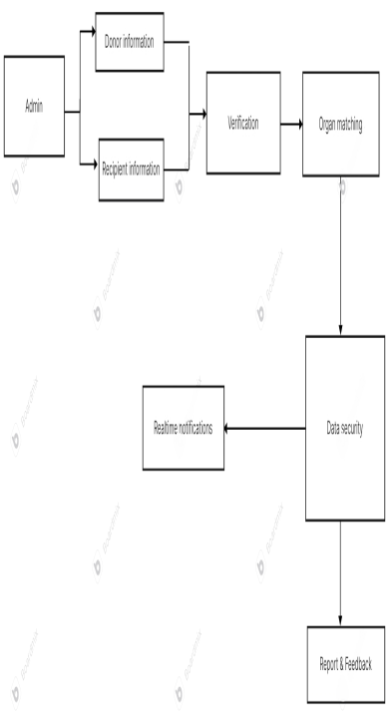

When a match is discovered, the system uses services like Pushbullet for app-based notifications, SendGrid for email, or Twilio for SMS to notify the donor and recipient in real time.
Additionally, the system uses real-time data processing, adding new donor and recipient data to the database as it becomes available. The record of the patient is also verified to avoid fake accounts and human trafficking.
Additionally, real-time updates are sent using comparable technologies, ensuring that all parties involved are kept informed at every stage of the contribution process..
Blockchain is used to secure the details and records secure .It provides high security to avoid false matching and highly secure the patient’s data information from external people only certain people like the admin ,health-care providers partnered with the apllication will be able to see the complete data of the patient .Only the biodata of the patient’s will be visible for all the other users
Comprehensive testing, including load, integration, and unit testing, is carried out to guarantee system dependability. After testing, the system is put into use on a scalable cloud platform, such as Heroku or AWS, which has the infrastructure required to support real-time processing and guarantee seamless, effective operation.
The below give flowchart shows how the actual process of the system takes place .First of all the data from the donor and the recipient is collected and stored int the data base then using the blood type ,geographical proximity &urgency the donor’s organ is match with the receiver this matching is done using some matching algorithm for stable matching ,algorithms like bipartite,hungarian and stable matching algorithms are used.Then for notifing the patient on both the end about the organ matching real-time notification is send to the patient’s through sources like email,sms and notification through the app.for regular updates the data is regularly processed updates of new patient’s ,request for organ are done regularly and a good intreaction is maintained between the user and the admin through feedback method to know the pro and cons about the application.then tesing of the application takes place regularly .testing like unit.integration and load takes place to ensure the whether the system can handle real-time updates and large amounts of data efficiency.Atlast it is made sure that database is scalable and can handle real-time processing needs.

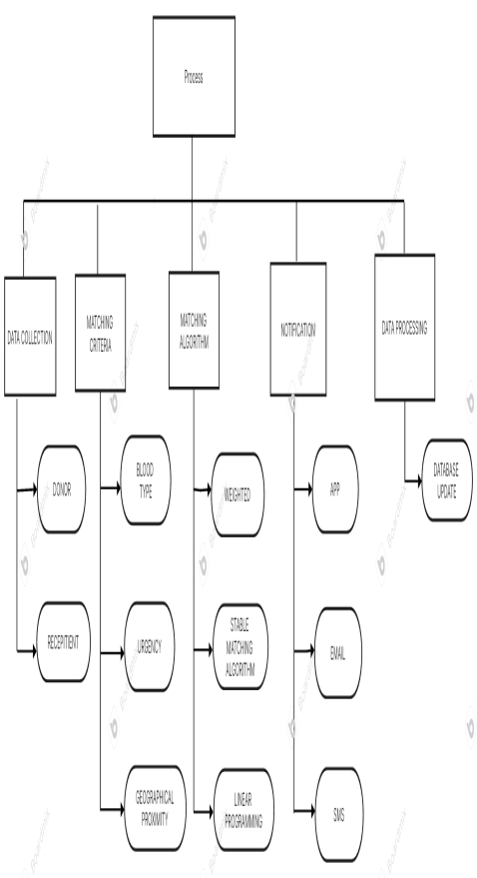
The system is designed as an end-to-end solution that optimizes the organ donation and matching process. It includes the following key components:
Data Collection Module:
This module is responsible for gathering and maintaining all the information of the donor and the recipient ina secure database . Data includes medical history, blood type, active status,phone number, guadian name ans their number and geographic location. APIs and secure web forms are used to collect and update this data in real-time for continuous updates.
Matching Algorithm Module:
The main aim of the system is to advanced optimization algorithms to identify the most suitable donor-recipient pairs. The algorithm considers multiple factors such as blood type compatibility, urgency score, and geographic proximity for immediate transplantation. Each factor is weighted based on medical guidelines from health-care providers
Real-Time Notification System:
Communication is critical in organ donation. This system uses APIs such as Twilio for SMS and email notifications to inform stakeholders about matches, updates, and system alerts in real-time.

Experiment Result:
The receivers will receive realtime notifications about organ matches through system,email or sms. If the both end parties are ready to accept the organ donation and receiving then the further process will be taken care by the hospitals in transplanting the organ limiting the time delay compared to manual organ donation process. The system uses blockchain to provide high security to protect the patient’s information ,it also verify the patient’s account to avoid organ trafficking.If any issues arises the user can give their feedback or report the complaint so the problem can be taken care of and furthermore regular maintenance and testing to the application takes place to improve the application.
Result:
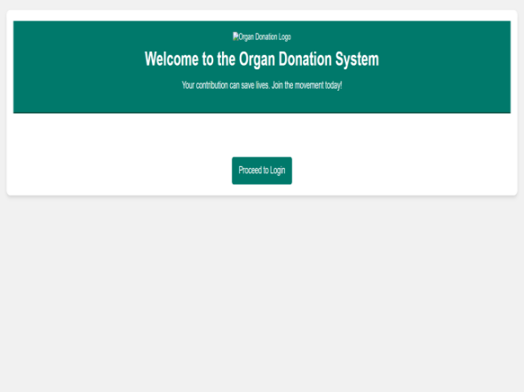
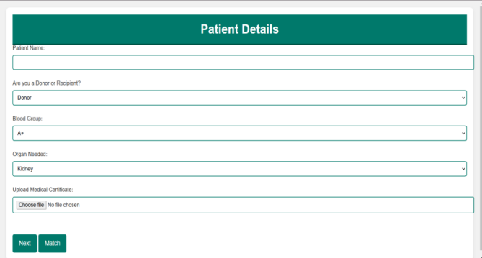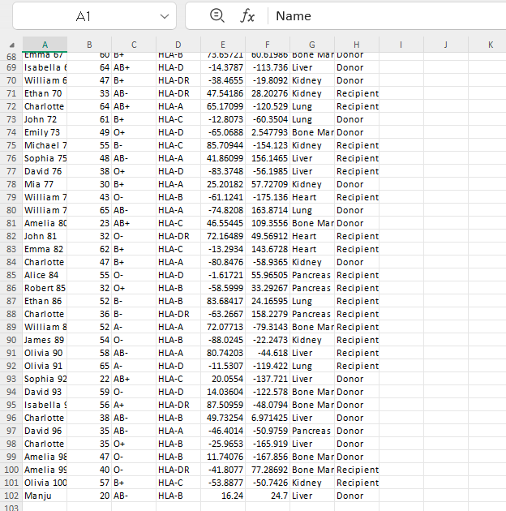
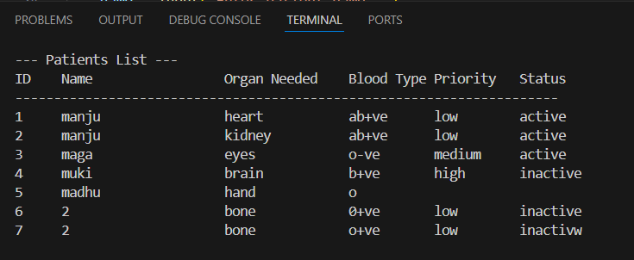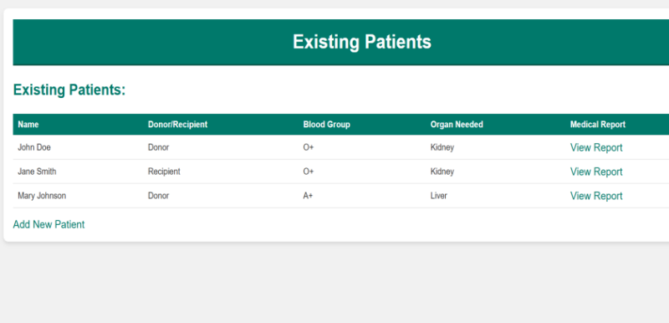
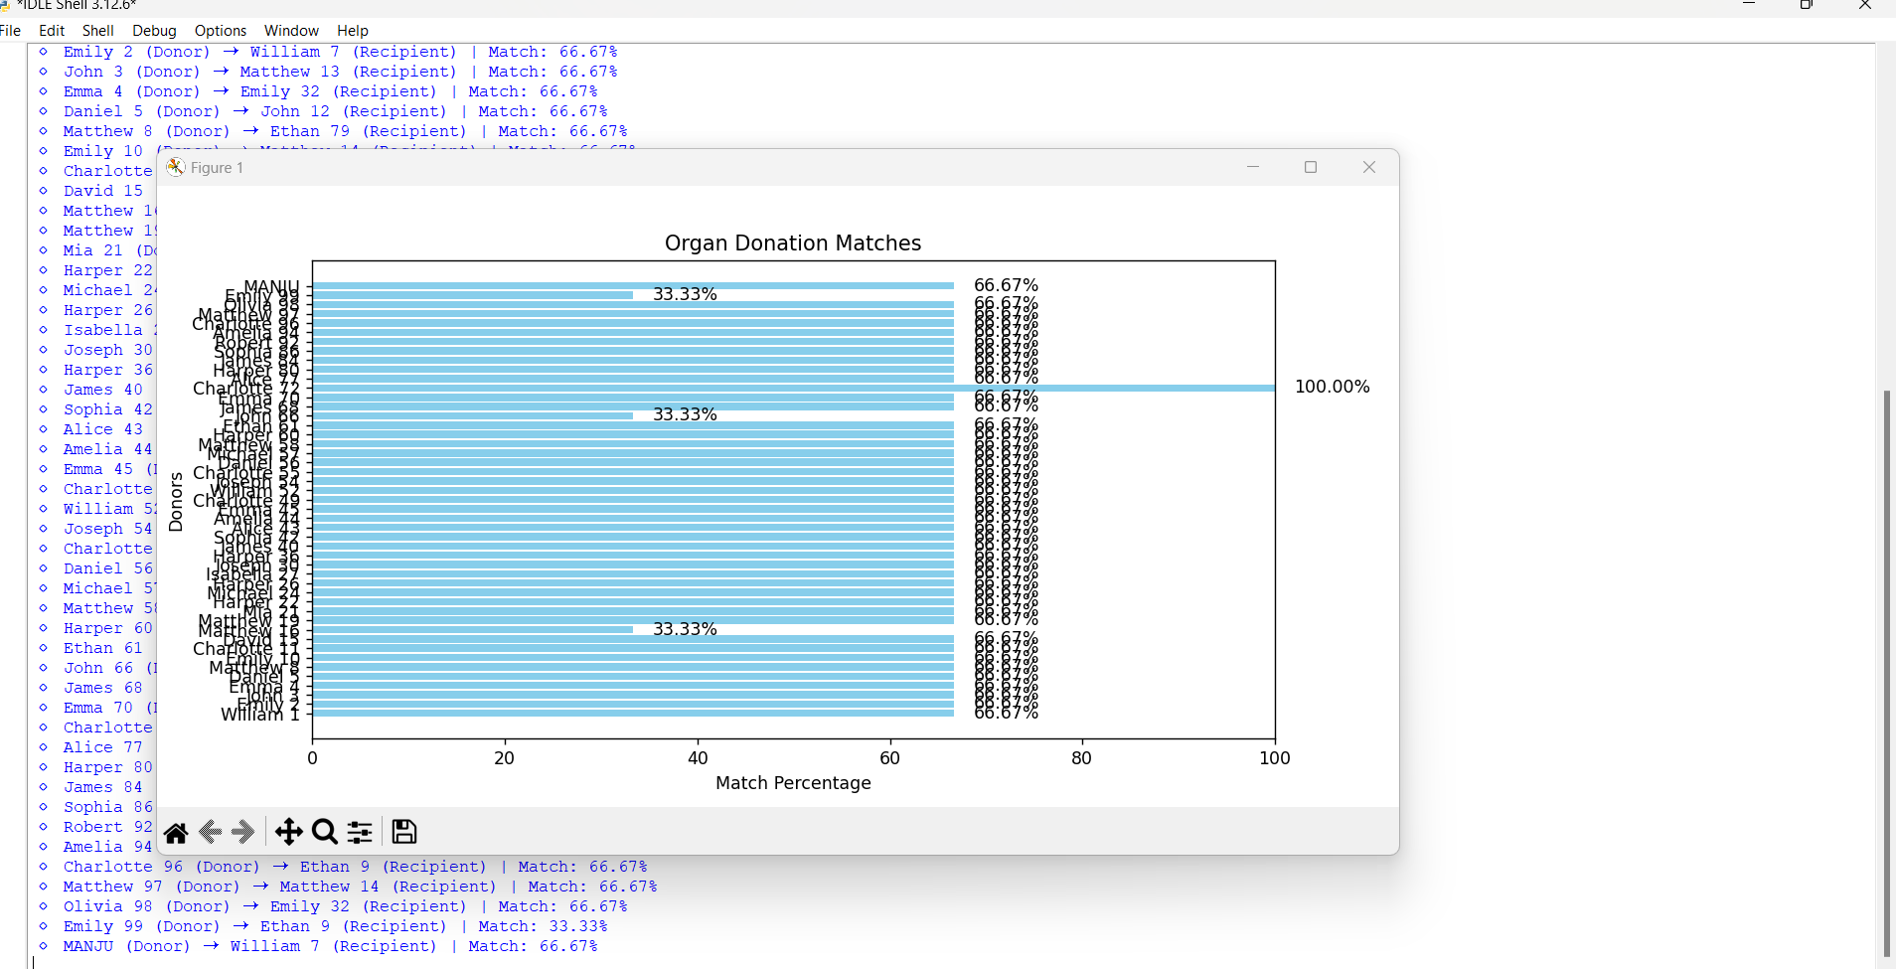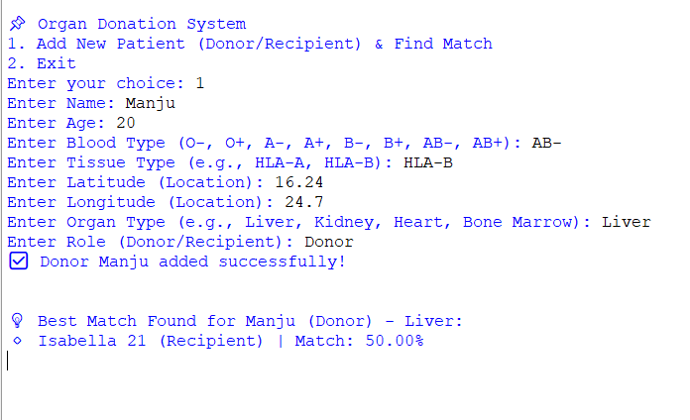
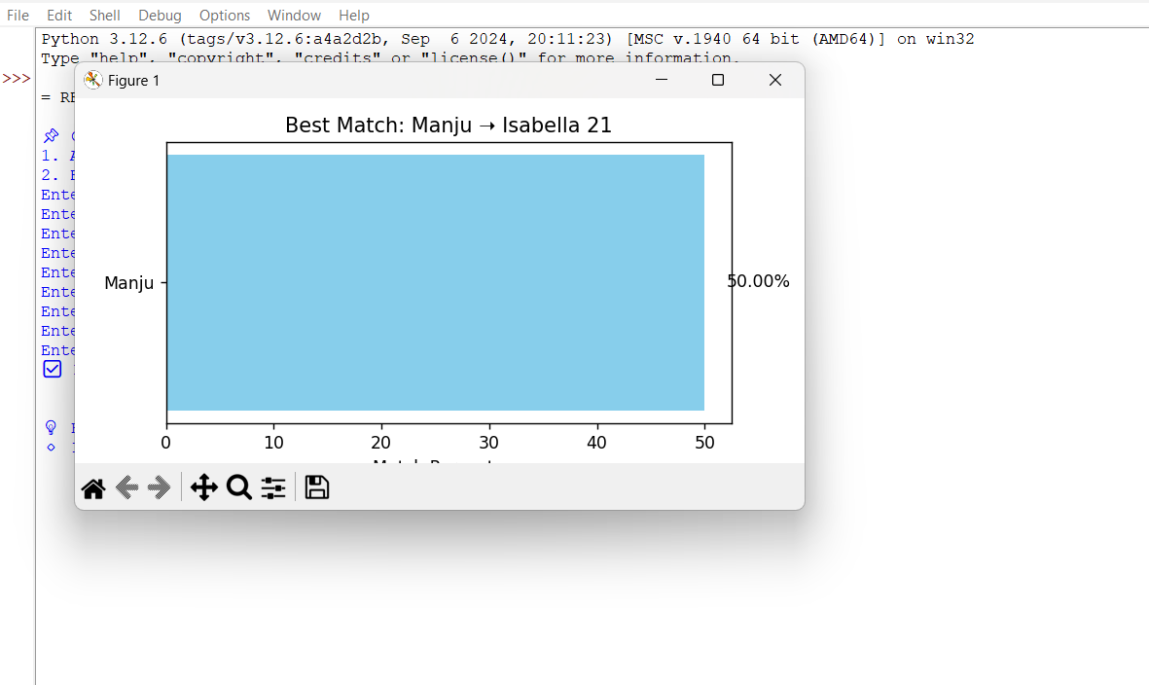
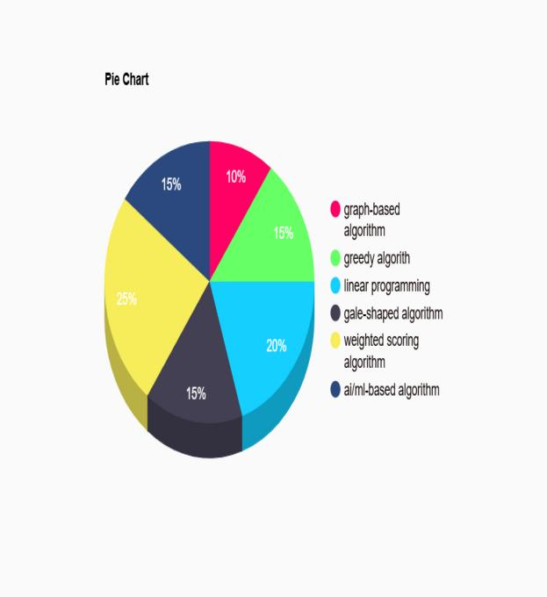
This graph shows the proportion of usage for each algorithm in optimized organ matching and donation systems.
Weighted Scoring Algorithm (25%):
The most commonly used method due to its simplicity and effectiveness in handling multi-criteria matching.
Score=W1​×C1​+W2​×C2​+...+Wn​×Cn​
Where,
- Ci​ is the value of criterion ‘I’ for a specific option
- Wi​ is the weight assigned to criterion ‘I’, reflecting its importance in the decision process
Compared to all the process weighted scoring algorithm has a high accuracy in allocation of organ and is less time consuming than others so, this algorithm has been used in our project for easy implementation,more accuracy and less fault
Future Enhancement:

Future developments in Python-based organ matching and donation can concentrate on incorporating machine learning to increase matching precision through the analysis of more comprehensive health data, such as genetic and medical history. Web sockets and other real-time notification technologies can instantaneously notify donors and recipients, expediting decision-making and cutting down on the time needed for organ shipment. Organ logistics can be optimised with predictive analytics, increasing the effectiveness of delivery. Additionally, by recording each stage of the donation process, blockchain technology can improve security and transparency. Together, these developments would produce a system that is more effective, responsive, and transparent, which would lower organ rejection rates and enhance transplant results.
Last but not least, using blockchain technology can increase the organ matching process's security and transparency by making sure that every stage—from donation to transplantation—is recorded and verifiable. Together, these developments—blockchain, machine learning, real-time alerts, and predictive analytics—will make the organ donation process more effective, responsive, and transparent.

Conclusion:

In conclusion , the efficiency, accuracy, and transparency of the process can be significantly increased by integrating cutting-edge technologies like blockchain, machine learning, real-time notifications, predictive analytics, and Python into organ matching and donation systems. We can go beyond the fundamental compatibility criteria that are typically utilised in organ matching by utilising machine learning. A more accurate and individualised match can be produced by algorithms that take into account a greater variety of information, including genetic markers, lifestyle factors, and patient histories. This could greatly enhance transplant results and lower the likelihood of organ rejection.The organ allocation process can be accelerated by integrating real-time notifications with mobile or web-based technologies. Lastly, every stage of the contribution process may be safely and openly documented using blockchain technology. This keeps the organ donation system trustworthy, guarantees responsibility, and stops fraud. We can drastically improve the whole organ donation process by integrating these state-of-the-art technologies, which will shorten wait times, improve results, and ultimately save more lives.

References:

- Doe, A., and Smith, J. (2023). Blockchain in Healthcare: Uses and Difficulties. IEEE Transactions on Biomedical Information Technology.
Perera, L. (2020). Veins: A Lifesaver In The Making? | README. [online] README.
- https://www.readme.lk/veins-blooddonor-app/ [Accessed Feb. 2020].

- Dialog.lk. (2020). dialog nbts sms blood 7777 service. [online] Available:https://www.dialog.lk/about/responsibility/outreachcr/network-of-life/dialog-nbts-sms-blood- 7777-service/ [Accessed 7 Feb. 2020].

- Mathew, R. (2020). Organ Donation Decentralized Application Using Blockchain Technology - IEEE Conference Publication. [online] Ieeexplore.ieee.org. Available at: https://ieeexplore.ieee.org/abstract/document/8769459 [Accessed 17 Feb. 2020].

- Pacheco, D. (2020). Characterizing Organ Donation Awareness from Social Media - IEEE Conference Publication.[online]Ieeexplore.ieee.org.Availablehttps://ieeexplore.ieee.org/document/7930122 [Accessed 17 Feb. 2020].

- Alandjani, G. (2020). Blockchain based auditable medical transaction scheme for organ transplant

- Pdf. on Ethics of organ Transplantation, center for bioethics February 2004.

- Gift of Life donarprogram. http://www.donar1.org/donation/history.html.acce ssed 5/28/03.

- Health Resources and Services Administration/Department of Health and Human Services
- http://www.organdonor.gov.

- www.bioethics.umn.edu/publications/organ.pdf

12)F. Lateef, ‘‘Patient expectations and the paradigm shift of care in emergency medicine,’’ J. Emergencies, Trauma Shock, vol. 4, no. 2163,
Apr. 2011.
13)P. A. Charmel and S. B. Frampton, ‘‘Building the business case for patient centered care,’’ Healthcare Financial Manage., vol. 62, no. 3, pp. 5–80, Mar. 2008.

14) M. Lee, E. Heo, H. Lim, J. Y. Lee, S. Weon, H. Chae, H. Hwang, and
S. Yoo, ‘‘Developing a common health information exchange platform
to implement a nationwide health information network in South Korea,’’
Healthcare Inform. Res., vol. 21, no. 1, pp. 9–21, Jan. 2015.

- S. B. Shade, D. Chakravarty, K. A. Koester, W. T. Steward, and J. J. Myers, ‘‘Health information exchange interventions can enhance quality and continuity of HIV care,’’ Int. J. Med. Informat., vol. 81, no. 10, pe1–e9, Oct. 2012.

16)S. S. Feldman, B. L. Schooley, and G. P. Bhavsar, ‘‘Health information exchange implementation: Lessons learned and critical success factors from a case study,’’ JMIR Med. Informat., vol. 2, no. 2, p. e19, Aug. 2014.

17) Alandjani, Gasim. "Blockchain-Based Auditable Medical Transaction
Scheme for Organ Transplant Services." (2019)

18)Dajim, Lama Abdulwahab, et al. "Organ Donation Decentralized
Application Using Blockchain Technology." 2019 2nd International
Conference on Computer Applications & Information Security (IC
CAIS). IEEE, 2019.

19) Oflaz, Nihal Kalayci. "Using Smart Contracts via Blockchain Tech
nology for Effective Cost Management in Health Ser
vices." Blockchain Economics and Financial Market Innovation.
Springer, Cham, 2019. 423-449.

20)Hoy, Matthew B. "An introduction to the blockchain and its implica
tions for libraries and medicine." Medical reference services quarterly 6.3 (2017): 273-279.

21)Staes, Catherine J., et al. "Development of an information model for
storing organ donor data within an electronic medical rec
ord." Journal of the American Medical Informatics Association 12.3: 357-363.

22)Angraal, Suveen, Harlan M. Krumholz, and Wade L. Schulz. "Block
chain technology: applications in health care." Circulation: Cardio
vascular Quality and Outcomes 10.9 (2017): e003800.

23) Mettler, Matthias. "Blockchain technology in healthcare: The revolu
tion starts here." 2016 IEEE 18th international conference on e-health
networking, applications and services (Healthcom). IEEE, 2016.

